**Excel Assignment - 9**

**1. What are the different margins options and do we adjust the margins of the excel worksheet?**

There are **four** margins you can specify: top, bottom, left, and right. Each margin refers to the distance from the edge of the paper to where the information in your worksheet can be printed.

Right-click on one of the selected cells and choose "Format Cells" from the context menu. In the "Format Cells" dialog box, click on the tab for "Alignment." In the "Cell Margins" section, enter the amount of space that you want around the cells. You can enter different values for top, bottom, left, and right.

**2. Set a background for your table created.**

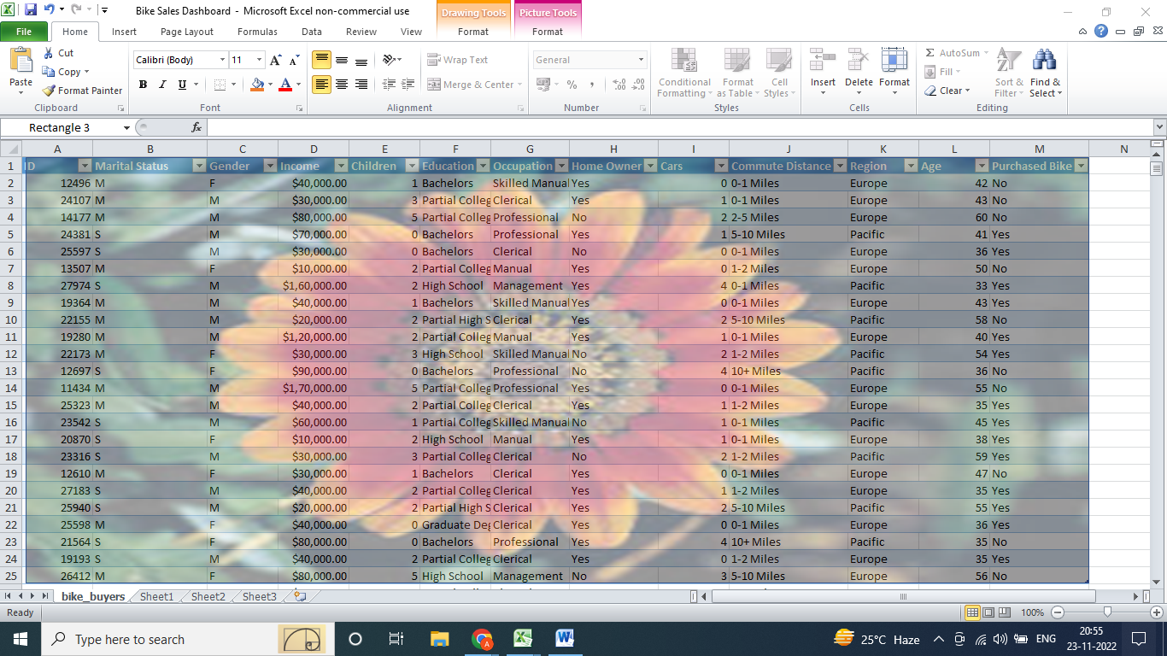

**3. What is freeze panes and why do we use freeze panes? Give**

**examples.**

When you freeze panes, **Excel keeps specific rows or columns visible when you scroll in the worksheet**. For example, if the first row in your spreadsheet contains labels, you might freeze that row to make sure that the column labels remain visible as you scroll down in your spreadsheet.

**4. What are the different features available within the Freeze Panes**

**command?**

* Freeze pane. ...
* Freeze Top row. ...
* Freeze First column.

To keep an area of a worksheet visible while you scroll to another area of the worksheet, go to the View tab, where you can Freeze Panes to lock specific rows and columns in place, or you can Split panes to create separate windows of the same worksheet.

**5. Explain what the different sheet options present in excel are and what they do?**

Since an Excel sheet is one of the core elements of the workbook, there are multiple core options to perform from the Sheet Options. We can access various sheet options by using the following ways:

* Ribbon Sheet Options
* Right-click Sheet Options

**Ribbon Sheet Options**

It mainly has four toggle options: two for **Gridlines** and two for **Headings,** and they can be turned on and off by selecting and deselecting the checkboxes.

* **Gridlines:**
  + **View:** This option allows users to show/ hide gridlines within the active worksheet. Turning off this option removes the gridlines from the sheet and displays a blank Excel sheet.
  + **Print:** This option allows users to show/ hide gridlines on an Excel document that will be printed on paper.
* **Headings:**
  + **View:** This option allows users to show/ hide headings within the active worksheet. Turning off this option removes the headings from the current sheet's headers and footers.
  + **Print:** This option allows users to show/ hide headings on an Excel document, which is to be printed on paper.

**Right-click Sheet Options**

### Insert

While working on Excel, we may sometimes need more sheets. For this, we need to go to the Sheet options by right-clicking the worksheet name on the sheet tab, then select Insert from the list. As soon as we click the Insert, the new blank worksheet will appear in the current workbook.

### Delete

Excel also allows us to delete the undesired sheets from the workbooks. For instance, suppose that we only want to organize our data in a single sheet, then deleting the remaining sheets will give a professional and clean look to our workbook.

### Move or Copy

When we need to duplicate the data from one sheet to another in Excel, we can use the Move and Copy option from the right-click sheet options list. We must first right-click on the sheet that we wish to copy and then select the **'Move and Copy'** option.